8 July 2026

Dear Student

SUMMER EXAM RESULTS

We would like to invite you to collect your GCSE exam results and any other results for qualifications you have been awarded, from school on Thursday 20 August between 09.30 – 11:00 am.

It would be preferable if you could collect and sign for them in person, however, a parent/carer may collect on your behalf but they have to be in possession of the enclosed Candidate Permission Form signed by yourself. They may be asked for proof of identity before being allowed to take the result slips.

Certificates will be available later in the year and we will send you another letter informing you of the arrangements for collection.

We look forward to seeing you on 20 August.
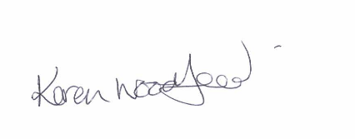
Kind regards

Karen Woodford
Examinations Officer

